BAI3270 PeopleSoft Assignment 5
Using the information below create the complete working project.

Project: NAIT###_ Equipment

MENU > BAIST > NAIT###
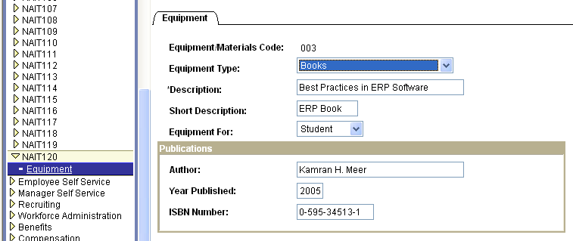

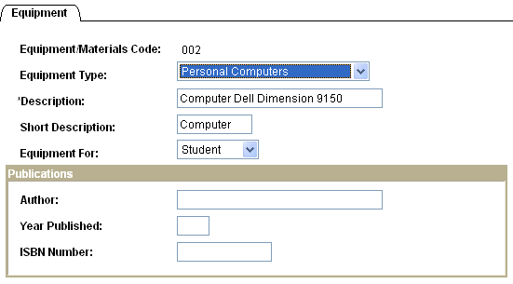

NAIT###_EQUIP_TYPE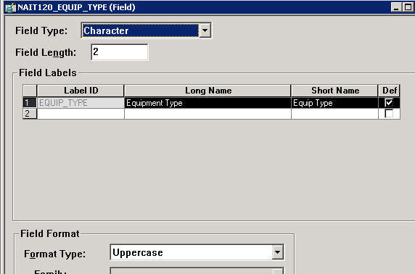
Translate Values Effective Dated: 01/01/1901
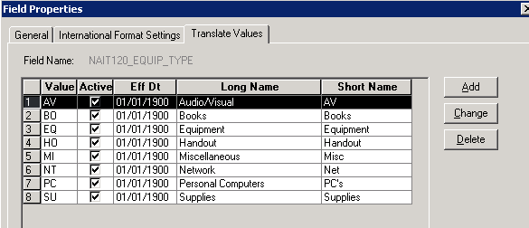

NAIT###_ROLE should already exist from a pervious lab. Add a new label.
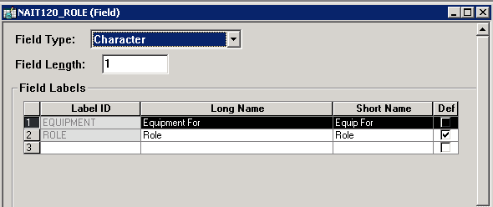

Page: NAIT###_EQUIP
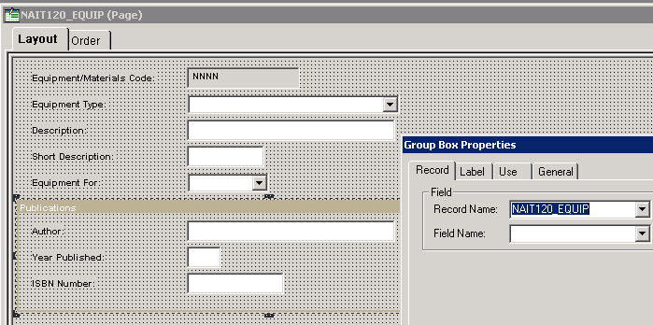

Record: NAIT###_EQUIP
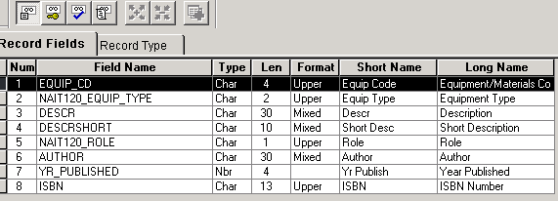
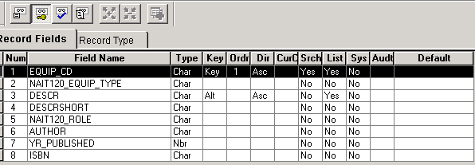
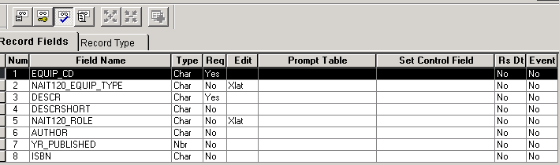

Please enter 5 rows of GOOD test data

